TrafficVision AI — Day 1 tasks( TEAM 3)

1. Understand the project statement
This is a web app where a city traffic department can log in, see live traffic conditions on a map/dashboard, get AI predictions about upcoming congestion, receive suggested alternate routes, and get alerted about accidents or jams — all backed by a database of traffic data and a simple ML model.

2. Objectives
- Provide real-time visibility into traffic conditions across monitored roads
- Predict congestion before it happens using historical and live data (AI/ML)
- Recommend alternate routes to reduce travel time during congestion
- Alert traffic operators and the public about accidents, closures, and jams
- Give traffic authorities analytics (trends, heatmaps) to plan long-term improvements

3. User roles
Role | Access | Key actions
Admin | Full access | Manage users, configure roads/sensors, view all analytics
Traffic operator | Operational access | Monitor live dashboard, respond to alerts, mark incidents
Public / commuter | Read-only, limited | View live map, get route suggestions, receive alerts

4. Research on smart traffic dashboards
Modern control-room dashboards combine a live map (color-coded green/yellow/orange/red for congestion levels) with a side panel showing incidents, vehicle counts, and infrastructure status such as bridges and underpasses.
Mature intelligent traffic systems bring together the traffic management centre, command dashboards, alert workflows, and operator interfaces into one operating core, so the dashboard is not just passive monitoring but supports active decisions.
Real intelligent traffic management platforms typically offer multimodal data integration, AI-based route planning, an efficiency dashboard, and urban analytics — a useful checklist to compare this project against.

5. UI inspiration
Common patterns across traffic dashboard UIs: a large live map as the centerpiece, color-coded status chips (green / amber / red), and a sidebar or side panel listing alerts and key metrics. This pattern was used as the base for the wireframe below.

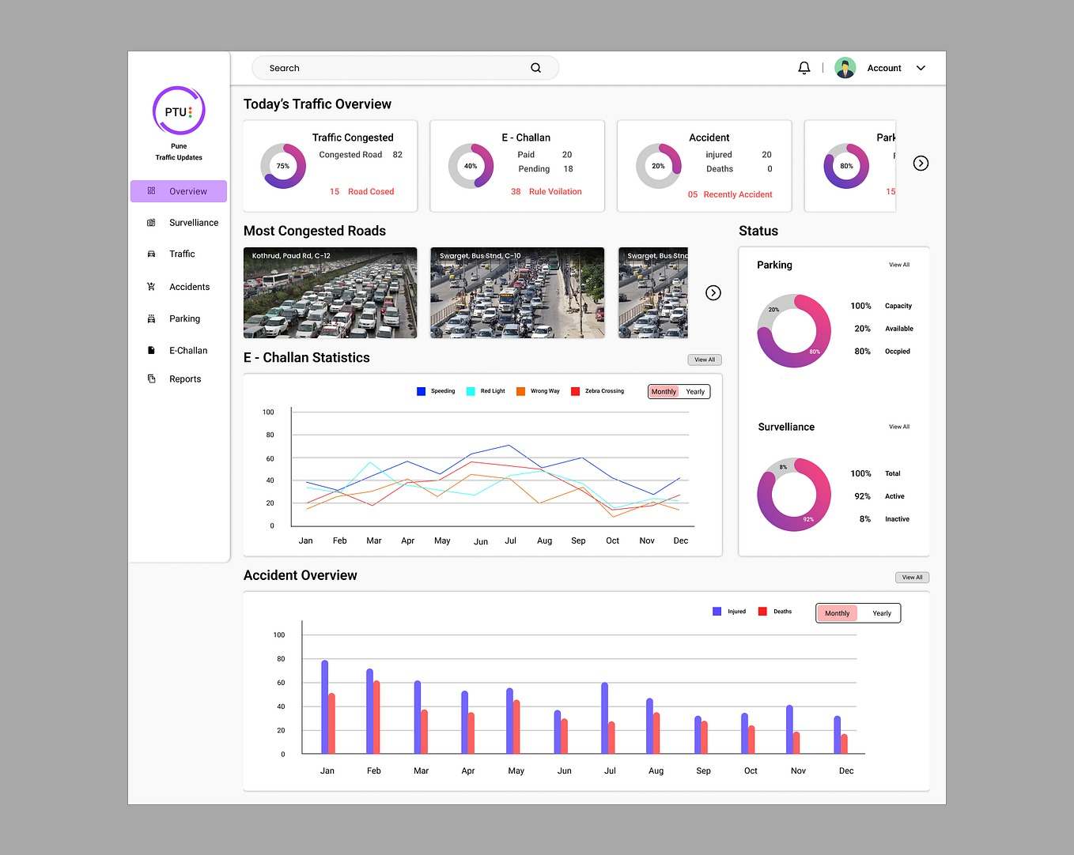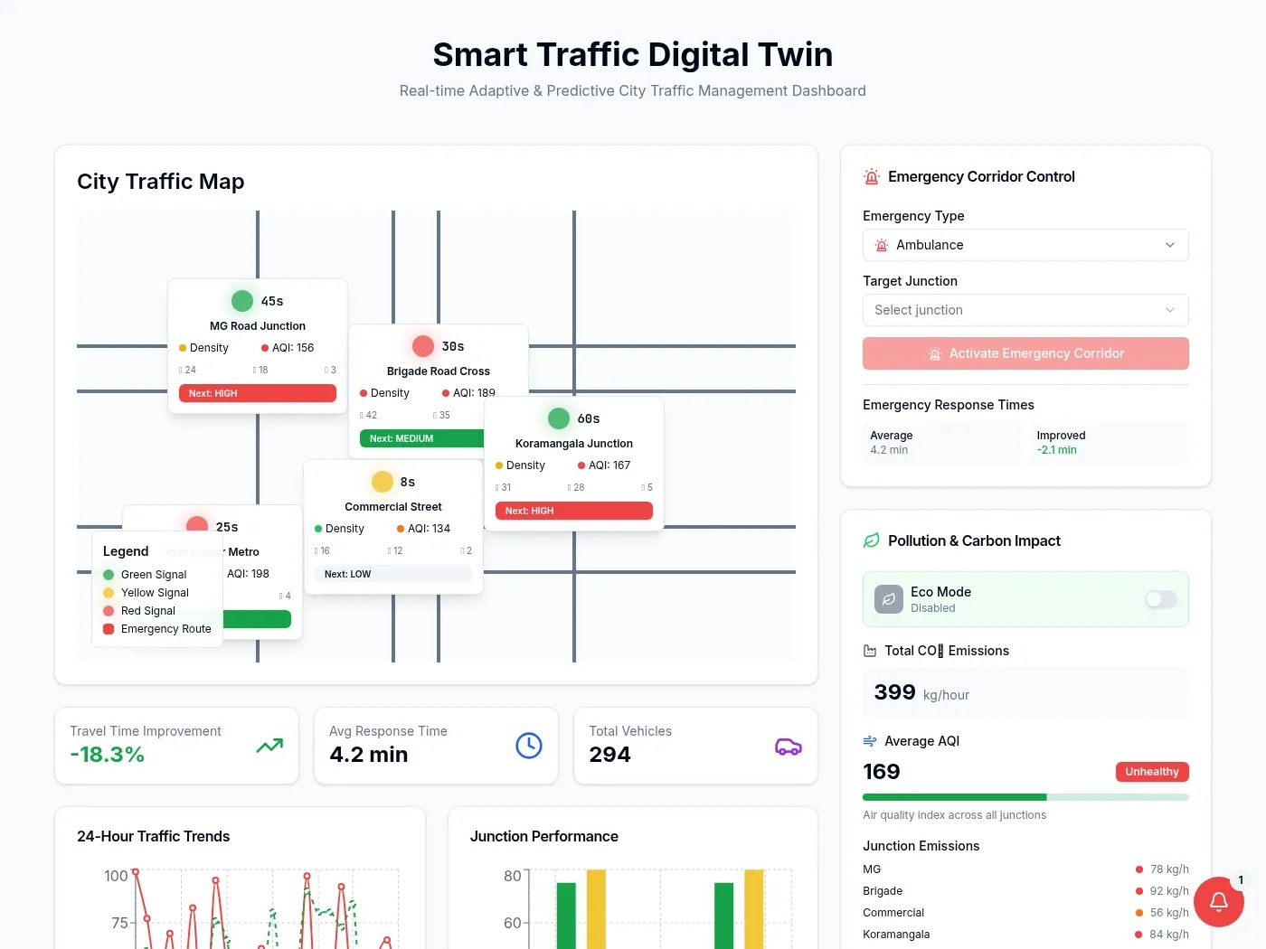

6. Initial wireframe
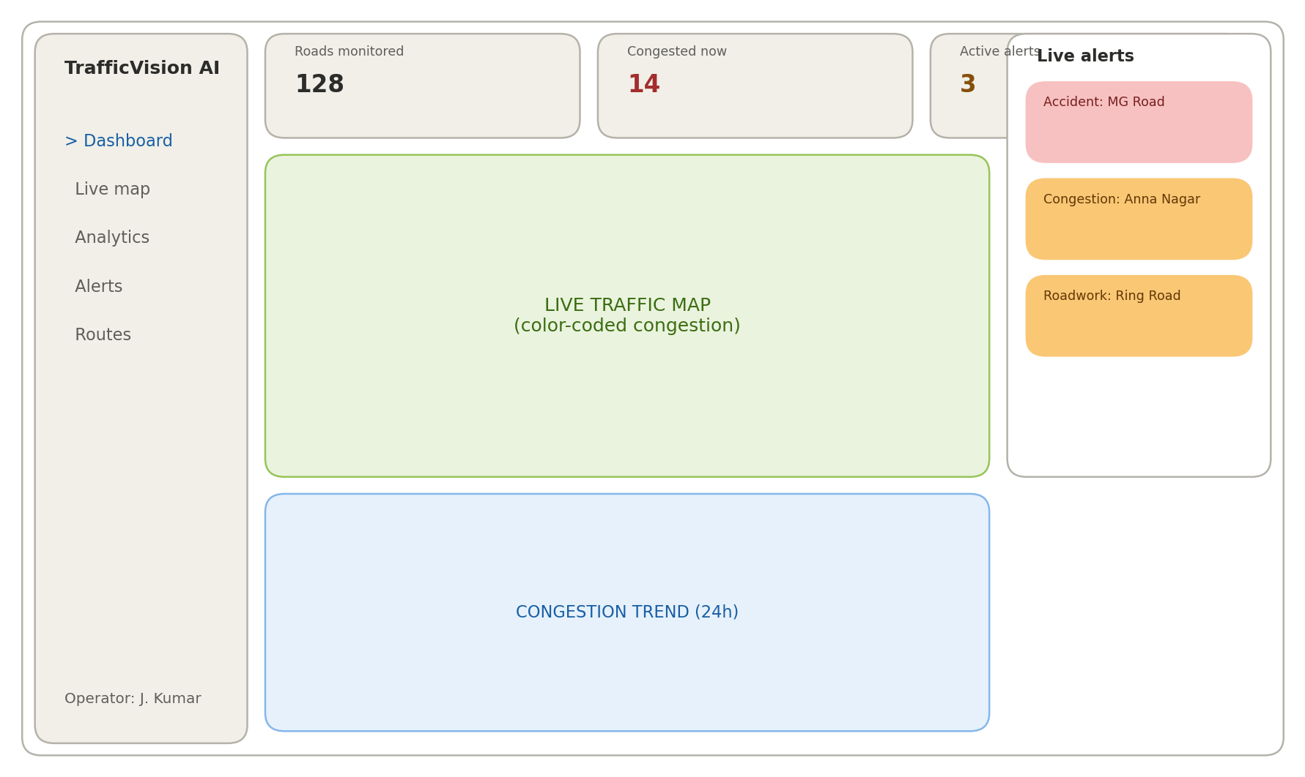

7. Draft ER diagram

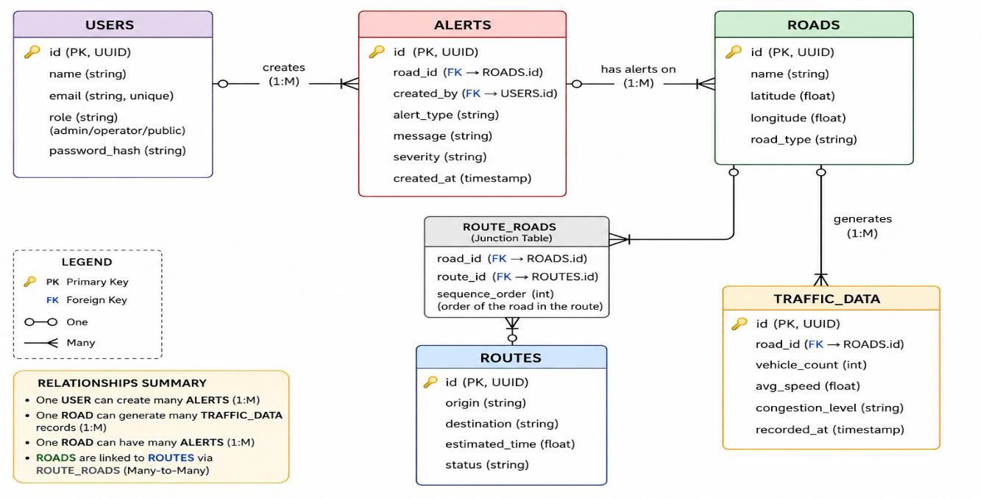

8. Research on congestion monitoring
- Fixed roadside sensors — inductive loop sensors, CCTV/video analytics, infrared, radar, and RFID sensors installed on roads; good accuracy but limited geographic coverage.
- GPS/probe-based — using GPS traces from vehicles or phones (as Google/Waze do); a road segment is often flagged congested when average speed drops significantly below normal (some studies use under 10 km/h as a threshold).
- Computer vision / deep learning — models such as YOLO or Faster R-CNN detect and count vehicles from camera feeds, then classify congestion as light, medium, or heavy based on density.

